CS4650

Assignment 3: Noise Filtering

Alexander Kochman

October 9, 2024

**Part 1, 2**

Original Image

Noisy Images

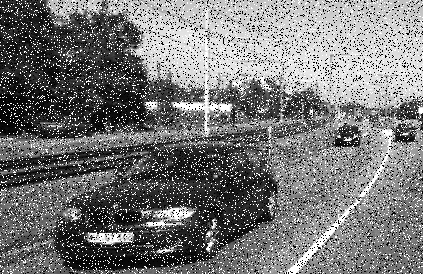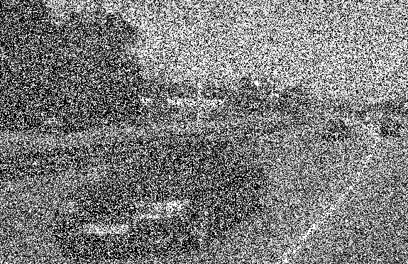

Filtered Images

Gaussian

Noise 1: sigma=2 Noise 2: sigma=2

Noise 1: sigma=7 Noise 2: sigma=7

Median

Noise 1: 7x7 Noise 2: 7x7

Noise 1: 19x19 Noise 2: 19x19

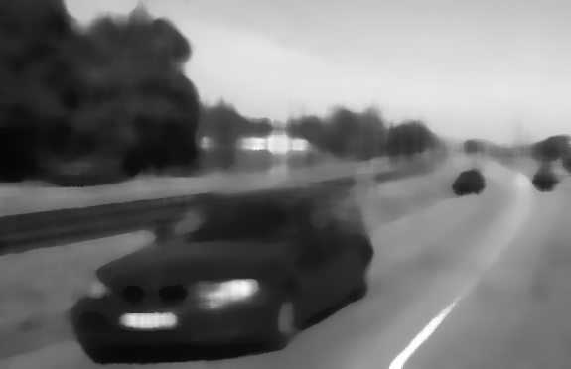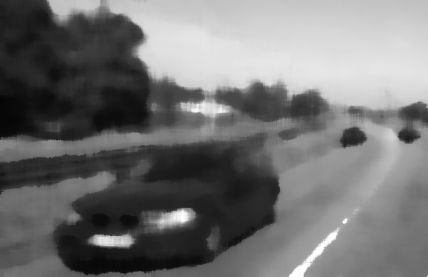

**Part 1, 2 Results**

|  |  |  |  |  |  |
| --- | --- | --- | --- | --- | --- |
|  | MSE | | | | |
| Noisy (not processed) | Gaussian Filter sigma=2 | Gaussian Filter sigma=7 | Median Filter (7x7) | Median Filter (19x19) |
| Test1Noise1 | 4357.134 | 511.109 | 892.932 | 203.735 | 558.373 |
| Test1Noise2 | 12983.429 | 2354.416 | 2473.259 | 400.794 | 583.466 |

**Part 1, 2 Analysis**

The gaussian and median filters are effective at removing noise, as shown above. For this specific noise, the median (7x7) filter produced the best results, with the lowest mean squared error. However, to consider these results acceptable, preserving the minute details of the image must not be of concern. In even the best result of the eight test cases, a small (but likely important) detail, the license plate sequence, cannot be discerned. While the gaussian and median filters can improve the noisiness of an image by blurring it, their usefulness extent for an image with this noise is making the larger objects and details slightly more visible.

**Part 3**

Original Images

Noisy Images

Filtered Images

Test 1: AMF 7x7 Test 1: AMF 19x19

Test 2: AMF 7x7

**Part 3 Results**

|  |  |  |  |  |  |
| --- | --- | --- | --- | --- | --- |
|  | MSE | | | Processing Time | |
| Noisy | Adaptive Median  Smax = [7x7] | Adaptive Median Smax=[19x19] | Adaptive Median Smax=[7x7] | Adaptive Median Smax=[19x19] |
| Test1Noise2 | 12983.429 | 202.156 | 177.936 | 4.7 | 5.7 |
| Test2Noise2 | 14175.325 | 1044.031 | 777.938 | 18.9 | 19.8 |

**Part 3 Analysis**

This approach created acceptable results. It took the more noisy images and filtered them to the point where small letters and characters were almost recognizable. If this approach was applied to images with a moderate amount of noise, it would create a very clear image. The larger the maximum window size, the more accurate the results were in comparison to the original image. This can be seen in the table under MSE. It is important to note that the MSE calculation supports that the adaptive median filter is a more acceptable result than the gaussian or median filter, specifically because of the common test case where the MSE is less using the adaptive median filter. The visual results confirm as much. The original noisy images are almost incomprehensible, while the features of the computed images are very obviously distinguished. In conclusion, the adaptive median filter is a much more acceptable method of filtering than the median or gaussian filters.